Jenkins_Pipeline Challenge
Step 1 — Verify the repository and branch
Open your existing EC2 terminal and run:
git ls-remote --symref https://github.com/betawins/spring3-mvc-maven-xml-hello-world-1.git HEAD
This checks whether GitHub is reachable and identifies the default branch.
If the command succeeds, clone the repository for inspection:
mkdir -p ~/jenkins-challenge1-inspection
cd ~/jenkins-challenge1-inspection

git clone https://github.com/betawins/spring3-mvc-maven-xml-hello-world-1.git
cd spring3-mvc-maven-xml-hello-world-1
Now run:
git branch --show-current
git log -1 --oneline
find . -maxdepth 3 -type f \( -name pom.xml -o -name Jenkinsfile -o -name mvnw \) -print
Check: Record the branch name and confirm where the pom.xml is located.
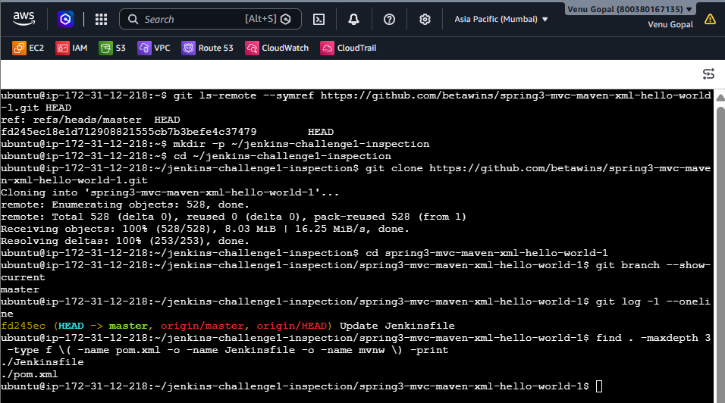
Step 2 — Inspect the Maven configuration
From inside the cloned repository, run:
find . -name pom.xml -print
If the root pom.xml exists, inspect it:
sed -n '1,240p' pom.xml
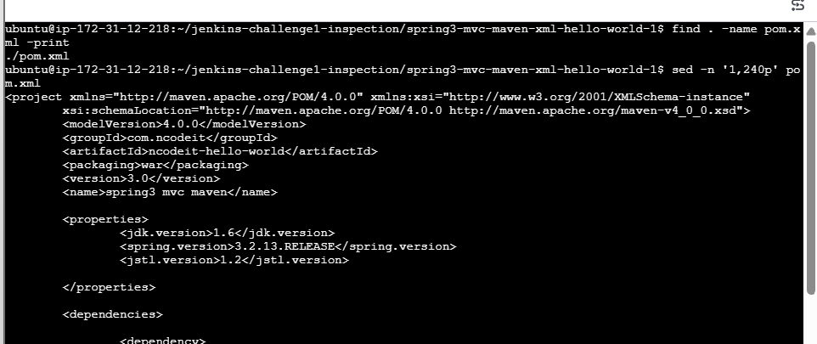
Check these items:
- Java source and target versions.
- Maven compiler plugin version.
- Packaging type, such as war or jar.
- Whether the project has multiple modules.
- Whether any special build profiles are required.
Also verify your installed versions:
java -version
mvn -version
Important: We must confirm that the project's Java and Maven requirements are compatible before running mvn clean package. Do not assume this older project will build with Java 21 without checking.
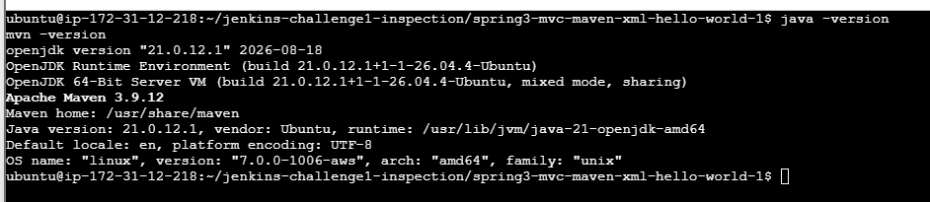
Step 3 — Check Jenkins tools
Open Jenkins:
http://YOUR-EC2-PUBLIC-IP:8081
Follow these clicks:
- Click Manage Jenkins.
- Open Tools (sometimes shown as Global Tool Configuration, depending on your Jenkins version).
- Under Maven installations, verify that the configured name is exactly Maven3.
- Confirm its Maven home is /usr/share/maven.
- Under JDK installations, check whether a JDK tool is configured.
You have already confirmed that the Built-In Node is online. Do not change its configuration unless we discover a specific problem.
Why this matters: Jenkins tool names are configuration identifiers. If a Jenkinsfile requests Maven3, the name must match exactly.
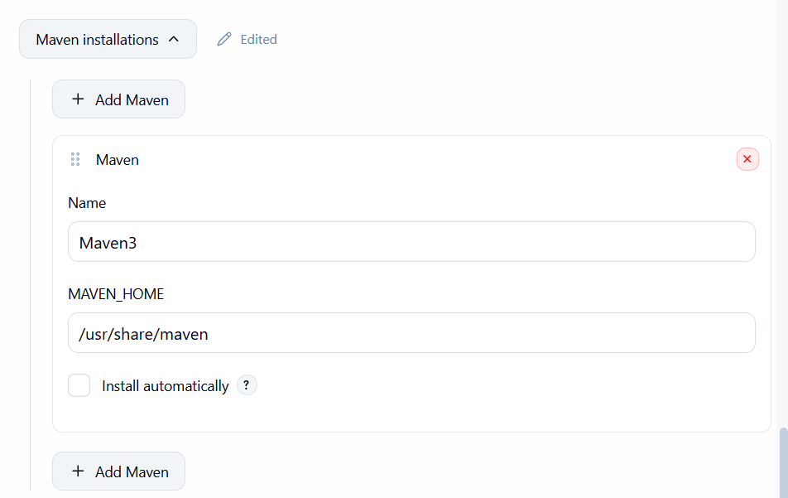
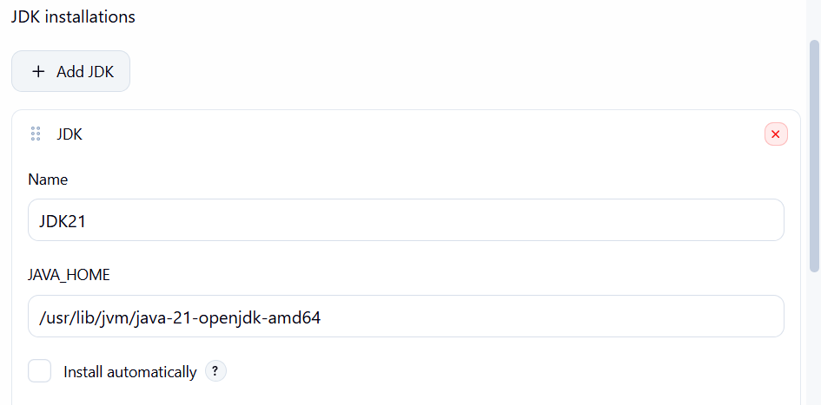
Step 4 — Create a Pipeline job

4.1 — Open Jenkins Dashboard
Click New Item in the left-hand menu.

4.2 — Enter the job name
challenge-1-declarative-pipeline
Select Pipeline, then click OK.

4.3 — Configure the Pipeline
Scroll to the Pipeline section. Set Definition to Pipeline script.
We will paste the Jenkinsfile directly into the job configuration.
Do not click Build Now yet.
Step 5 — Add the Declarative Pipeline Jenkinsfile
The following is the intended Jenkinsfile structure. Before running it, replace the branch placeholder with the branch verified in Step 1, and confirm the JDK configuration and Maven requirements from Steps 2–3.

pipeline {
agent any

tools {
maven 'Maven3'
}

options {
timestamps()
}

stages {
stage('Checkout') {
steps {
git branch: 'VERIFIED_BRANCH',
url: 'https://github.com/betawins/spring3-mvc-maven-xml-hello-world-1.git'
}
}

stage('Verify Tools') {
steps {
sh '''
echo "Checking Java version"
java -version

echo "Checking Maven version"
mvn -version

echo "Checking workspace"
pwd
ls -la
'''
}
}

stage('Build') {
steps {
sh 'mvn clean package'
}
}
}

post {
success {
echo 'Challenge 1 completed successfully!'
}

failure {
echo 'Pipeline failed. Check Console Output.'
}

always {
echo 'Pipeline execution finished.'
}
}
}
Understand the Jenkinsfile
Keyword | Meaning
pipeline | Defines the Declarative Pipeline.
agent any | Runs on any eligible Jenkins agent.
tools | Selects the configured Maven installation.
stages | Groups the pipeline's stages.
steps | Contains commands or pipeline steps to execute.
post | Defines actions to run after the pipeline finishes.
Note: This Jenkinsfile uses the Maven installation configured in Jenkins. It does not assume that a separate Jenkins-managed JDK tool exists. The Java used by the shell should still be checked in the tool-verification stage.
After confirming the placeholders and compatibility, paste the Jenkinsfile into the Script box and click Save.
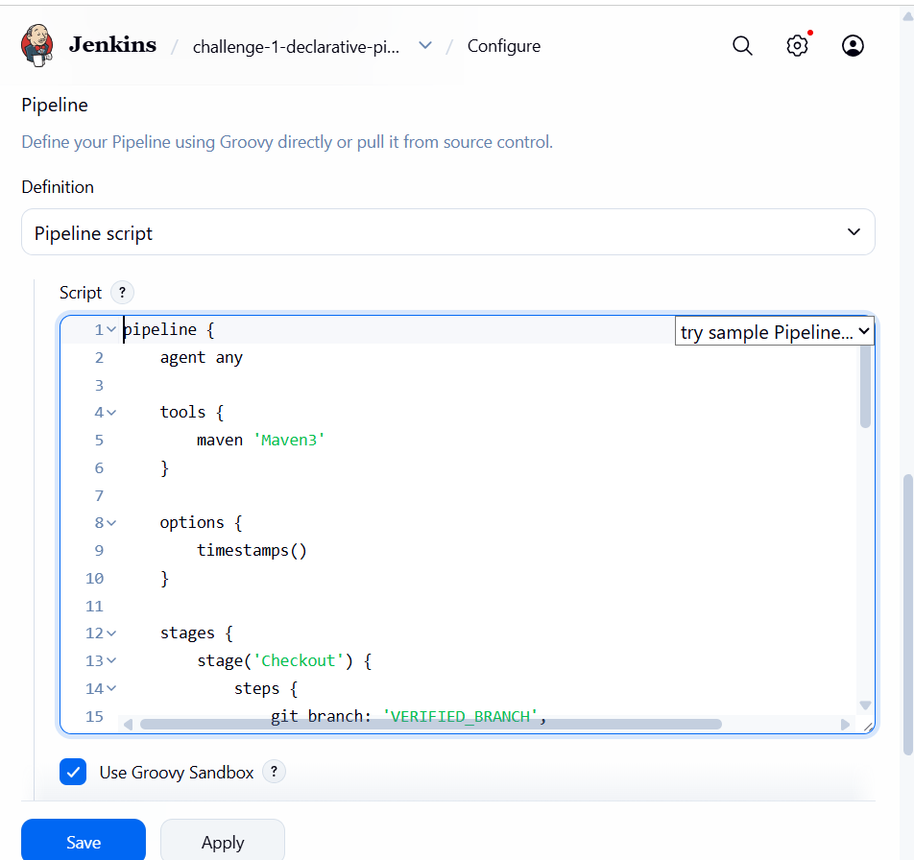
Step 6 — Run the pipeline
- Open challenge-1-declarative-pipeline.
- Click Build Now.
- Wait for the build to finish.
- Under Build History, click the latest build number.
- Click Console Output.
Look for these stages:
- Checkout
- Verify Tools
- Build
The final result should be Finished: SUCCESS.
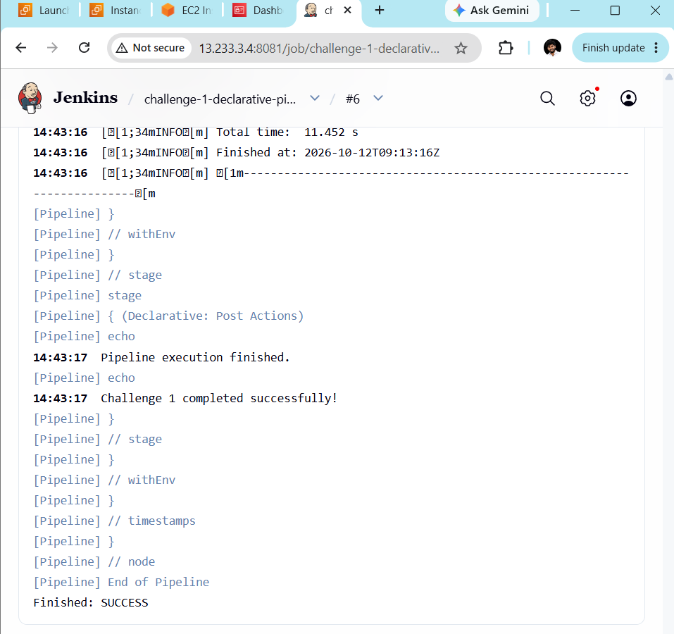
Step 7 — Verify the build output
If the build succeeds, inspect the workspace from the Jenkins build logs. For a Maven project, you should normally see a target directory and the packaged artifact expected by the project's packaging type.
For example, a WAR project may produce a file such as:
target/<project-name>.war
The actual filename depends on the POM. We should not assume it will be a WAR until we inspect the project configuration.
If the build fails, open Console Output and share the relevant error section. Do not change Java versions, Maven settings, or Jenkins permissions blindly.
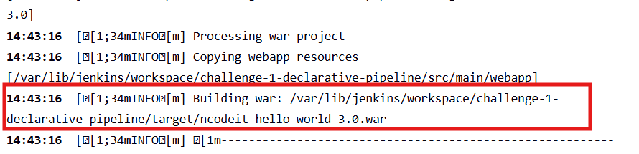

Challenge 2 — Scripted Pipeline
Objective: Create a Jenkins Scripted Pipeline that checks out source code from GitHub, verifies Java and Maven, builds the Maven project, and generates the WAR artifact.
Pipeline workflow
1. Checkout Code
GitHub repository
2. Verify Tools
Java and Maven
3. Build Project
mvn clean package
4. Archive Artifact
Save the generated WAR file in Jenkins
Step 1 — Create the Jenkins job
- Open your Jenkins dashboard: http://13.233.3.4:8081
- Click New Item.
- Enter the job name:
challenge-2-scripted-pipeline
- Select Pipeline.
- Click OK.
Step 2 — Configure the Pipeline
Scroll down to the Pipeline section.
Set the following values:
Setting | Value
Definition | Pipeline script
Script | Paste the Scripted Pipeline from Step 3
Keep the other settings at their defaults unless you need a specific change.
Step 3 — Paste this Scripted Pipeline
This pipeline uses your existing Jenkins tool names and overrides the old project's Java 6 compiler setting with Java 8 source/target compatibility, as we did in Challenge 1.

node {
timestamps {
try {
stage('Checkout') {
git branch: 'main',
url: 'https://github.com/betawins/spring3-mvc-maven-xml-hello-world-1.git'
}

stage('Verify Tools') {
def javaHome = tool 'JDK21'
def mavenHome = tool 'Maven3'

env.JAVA_HOME = javaHome
env.PATH = "${javaHome}/bin:${mavenHome}/bin:${env.PATH}"

sh '''
echo "===== Java Version ====="
java -version

echo "===== Maven Version ====="
mvn -version

echo "===== Workspace ====="
pwd
ls -la
'''
}

stage('Build') {
sh 'mvn -Djdk.version=1.8 clean package'
}

stage('Archive Artifact') {
archiveArtifacts artifacts: '**/target/*.war',
fingerprint: true
}

currentBuild.result = 'SUCCESS'
echo 'Challenge 2: Scripted Pipeline completed successfully!'
} catch (err) {
currentBuild.result = 'FAILURE'
echo "Pipeline failed: ${err}"
throw err
} finally {
echo "Pipeline finished with status: ${currentBuild.currentResult}"
}
}
}
Important: This is a Scripted Pipeline because it uses node {}, stage() and Groovy control flow (try/catch/finally), rather than the Declarative pipeline {} structure.
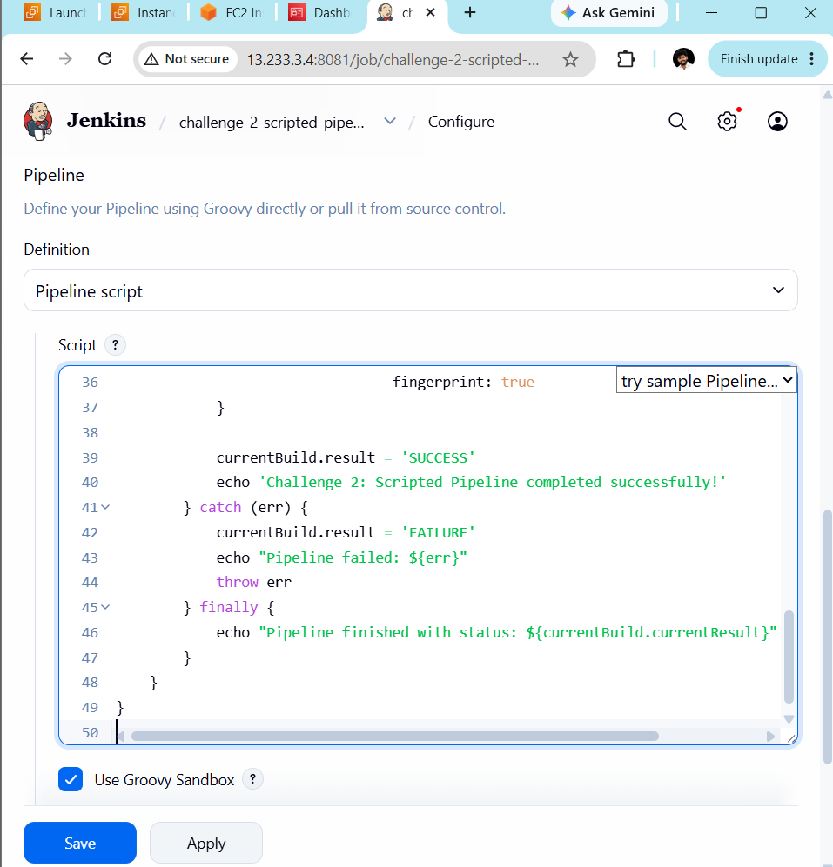
Step 4 — Save and run
- Click Save.
- On the job page, click Build Now.
- Under Build History, click the latest build number.
- Click Console Output.
- Wait for the build to finish.
Step 5 — Verify the result
Your expected stage flow is:
- Checkout
- Verify Tools
- Build
- Archive Artifact
A successful run should show Finished: SUCCESS. The archive stage should also report that the generated WAR file was archived.
If the archive stage says “No artifacts found”, don't assume the build itself failed; check whether Maven generated a WAR under target/ and adjust the archive pattern if needed.
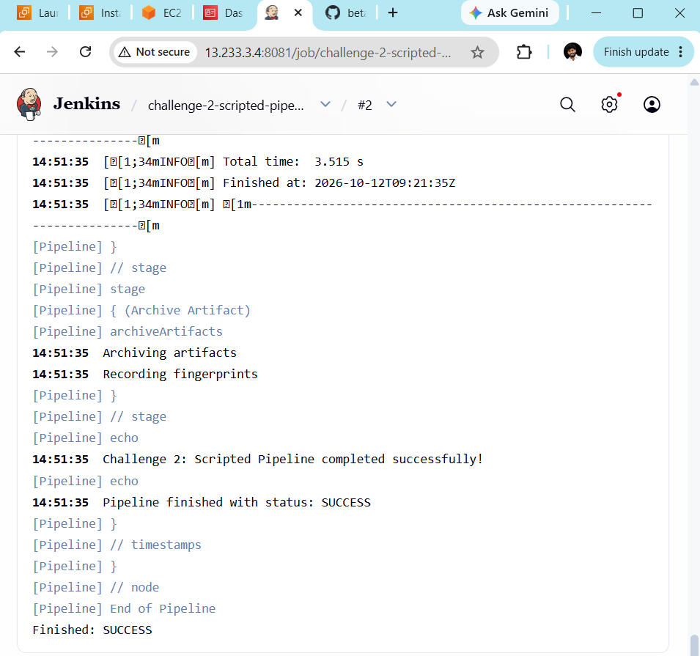
Step 6 — Troubleshooting
Error | What to check
No tool named JDK21 | Verify Manage Jenkins → Tools → JDK installations and the exact tool name.
No tool named Maven3 | Verify the Maven installation name under Manage Jenkins → Tools.
Source option 6 is no longer supported | Check that the build command includes -Djdk.version=1.8.
Git checkout fails | Check the repository URL and branch name.
No artifacts found | Check the build output and the actual WAR file path under target/.

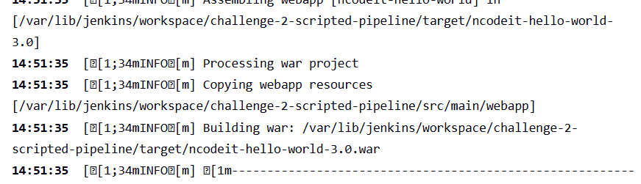

Challenge 3 — Parameterized Pipeline
Objective: Create a Jenkins pipeline that allows you to select a Git branch and Maven build command before starting the build.
We'll use the same GitHub repository and your existing JDK21 and Maven3 installations.
1. Select Build Parameters
Git branch + Maven goal
2. Checkout Selected Branch
3. Run Maven Build
4. Archive WAR Artifact
Step 1 — Create a new Jenkins job
- Open Jenkins: http://13.233.3.4:8081
- Click New Item.
- Enter this name:
challenge-3-parameterized-pipeline
- Select Pipeline.
- Click OK.
Step 2 — Configure the Pipeline
Scroll down to the Pipeline section.
- Definition: Pipeline script
- We'll add the script in Step 4.
Don't select Pipeline script from SCM for this exercise.
Step 3 — Add build parameters
For this challenge, we'll define parameters directly in the Jenkinsfile. Jenkins will register them after the first run.
The parameters will be:
Parameter | Type | Purpose
GIT_BRANCH | Choice | Select main or master
MAVEN_GOALS | Choice | Select clean package or clean test
Important: Use the branch names that actually exist in your repository. Challenge 2 encountered a missing main branch, so replace the sample branch choices below with your repository's confirmed branch names before running the pipeline.
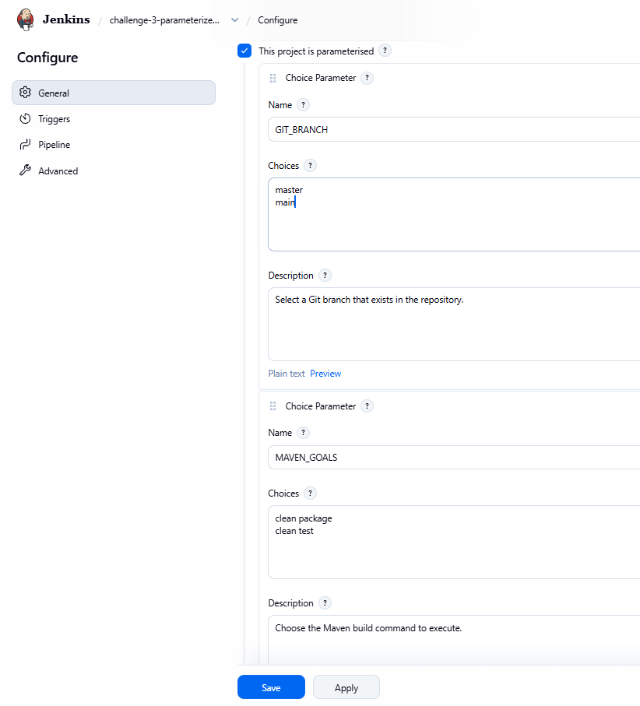
Step 4 — Paste this Jenkinsfile

properties([
parameters([
choice(
name: 'GIT_BRANCH',
choices: ['master', 'main'],
description: 'Select a branch that exists in the GitHub repository'
),
choice(
name: 'MAVEN_GOALS',
choices: ['clean package', 'clean test'],
description: 'Select the Maven build goal'
)
])
])

node {
timestamps {
try {
stage('Checkout') {
echo "Selected Git branch: ${params.GIT_BRANCH}"

git branch: params.GIT_BRANCH,
url: 'https://github.com/betawins/spring3-mvc-maven-xml-hello-world-1.git'
}

stage('Verify Tools') {
def javaHome = tool 'JDK21'
def mavenHome = tool 'Maven3'

env.JAVA_HOME = javaHome
env.PATH = "${javaHome}/bin:${mavenHome}/bin:${env.PATH}"

sh '''
echo "===== Java Version ====="
java -version
echo "===== Maven Version ====="
mvn -version
'''
}

stage('Build') {
echo "Selected Maven goals: ${params.MAVEN_GOALS}"

sh "mvn -Djdk.version=1.8 ${params.MAVEN_GOALS}"
}

stage('Archive Artifact') {
archiveArtifacts(
artifacts: '**/target/*.war',
allowEmptyArchive: true,
fingerprint: true
)
}

currentBuild.result = 'SUCCESS'
echo 'Challenge 3: Parameterized Pipeline completed!'
} catch (err) {
currentBuild.result = 'FAILURE'
echo "Pipeline failed: ${err}"
throw err
} finally {
echo "Pipeline finished with status: ${currentBuild.currentResult}"
}
}
}
Before saving: check the branch choices
The script above includes master and main as examples. Edit the choices list to include only branches confirmed to exist in the repository.
For example, if the repository's actual branch is master, use:
choices: ['master']
This prevents Jenkins from failing checkout because of a nonexistent branch.
Step 5 — Save and run the first build
- Click Save.
- Click Build Now.
- Open the latest build and select Console Output.
- Check the selected branch and build output.
The first run registers the parameters. Depending on the Jenkins version and job configuration, the parameters may only become available for selection after this initial run.
Step 6 — Run with parameters
After the initial run:
- Open the job page.
- Look for Build with Parameters.
- Select the desired GIT_BRANCH.
- Select the desired MAVEN_GOALS.
- Click Build.
Try clean package first. This should compile the application and package the WAR file.
You can later select clean test to run the test lifecycle. That selection does not package a WAR, so the archive stage may find no artifact; the pipeline allows an empty archive for that reason.
Step 7 — Verify the result
Expected stages:
- Checkout
- Verify Tools
- Build
- Archive Artifact
The final Console Output should show:
Finished: SUCCESS
For the clean package option, check whether the WAR was archived under the build's Artifacts section.
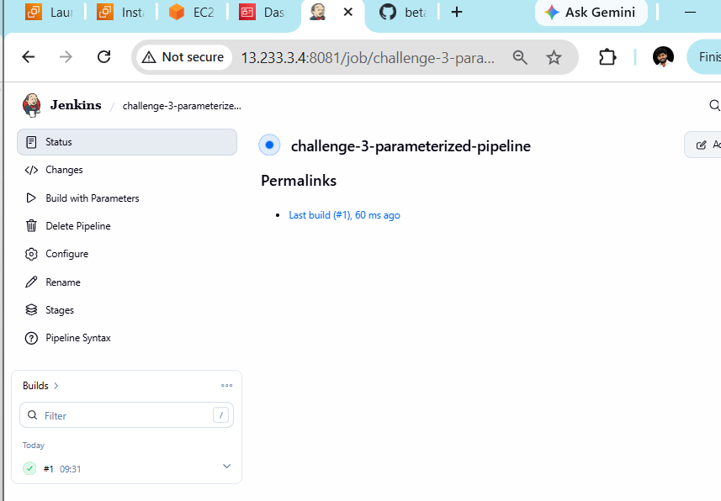
Step 8 — Troubleshooting
Error | Fix
Couldn't find any revision to build | Select a branch that exists in the repository.
No tool named JDK21 | Check the exact JDK tool name under Manage Jenkins → Tools.
No tool named Maven3 | Check the exact Maven tool name.
Source option 6 is no longer supported | Ensure the Maven command contains -Djdk.version=1.8.
Build with Parameters not visible | Complete the first run and reload the job page.
No WAR artifact | Use clean package instead of clean test.

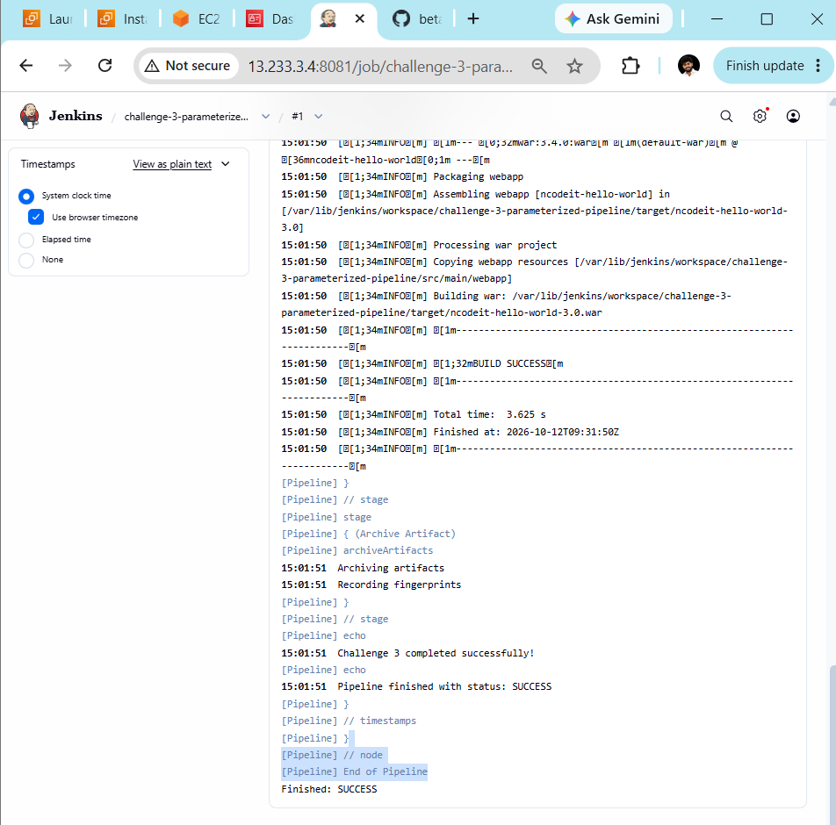

Challenge 4: Write sample pipeline skeletons
Objective: Create two Jenkins jobs to understand the basic structure of both pipeline types.
- 4A: Declarative Pipeline Skeleton
- 4B: Scripted Pipeline Skeleton
These are practice pipelines, so we won't need another EC2 server or any new installations.
Part A — Declarative Pipeline Skeleton
Step 1 — Create a Jenkins job
- Open Jenkins: http://13.233.3.4:8081
- Click New Item.
- Enter the name:
challenge-4a-declarative-skeleton
- Select Pipeline.
- Click OK.
Step 2 — Configure the Pipeline
Scroll down to the Pipeline section.
- Definition: Pipeline script
- Leave Use Groovy Sandbox enabled.
Step 3 — Paste this Declarative Pipeline

pipeline {
agent any

options {
timestamps()
}

stages {
stage('Initialize') {
steps {
echo 'Pipeline initialized'
}
}

stage('Checkout') {
steps {
echo 'Checkout stage - sample skeleton'
}
}

stage('Build') {
steps {
echo 'Build stage - sample skeleton'
}
}

stage('Test') {
steps {
echo 'Test stage - sample skeleton'
}
}

stage('Deploy') {
steps {
echo 'Deploy stage - sample skeleton'
}
}
}

post {
success {
echo 'Declarative skeleton completed successfully'
}

failure {
echo 'Declarative skeleton failed'
}

always {
echo 'Pipeline execution finished'
}
}
}
This is a skeleton, so the stages demonstrate the structure without actually checking out, compiling, testing, or deploying an application.
Step 4 — Save and run
- Click Save.
- Click Build Now.
- Open the latest build.
- Click Console Output.
Expected final result:
Finished: SUCCESS
You should see all five stages execute.
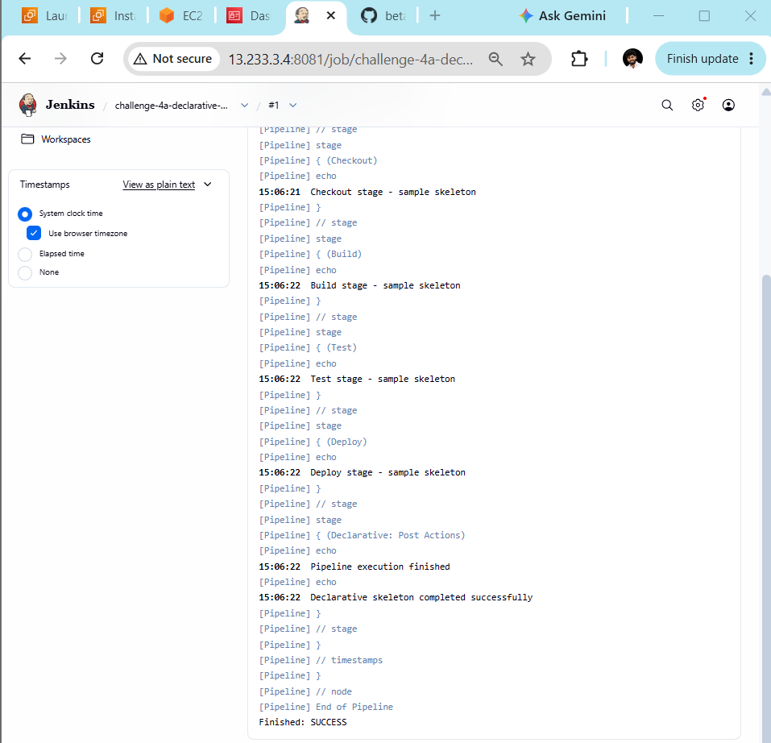
Part B — Scripted Pipeline Skeleton
Step 5 — Create another Jenkins job
- Return to the Jenkins dashboard.
- Click New Item.
- Enter:
challenge-4b-scripted-skeleton
- Select Pipeline.
- Click OK.
Step 6 — Paste this Scripted Pipeline
Scroll down to Pipeline → Script and paste:

node {
timestamps {
try {
stage('Initialize') {
echo 'Pipeline initialized'
}

stage('Checkout') {
echo 'Checkout stage - sample skeleton'
}

stage('Build') {
echo 'Build stage - sample skeleton'
}

stage('Test') {
echo 'Test stage - sample skeleton'
}

stage('Deploy') {
echo 'Deploy stage - sample skeleton'
}

echo 'Scripted skeleton completed successfully'
} catch (err) {
echo "Pipeline failed: ${err}"
throw err
} finally {
echo "Pipeline finished with status: ${currentBuild.currentResult}"
}
}
}
Step 7 — Save and run
- Click Save.
- Click Build Now.
- Open Console Output.
- Confirm the final status is Finished: SUCCESS.
Step 8 — Understand the difference
Feature | Declarative | Scripted
Main structure | pipeline {} | node {}
Stages | stages { stage { steps {} } } | stage() {}
Syntax | Structured and predefined | More flexible Groovy
Error handling | Often uses post conditions | Can use try/catch/finally
Best for | Standard CI/CD workflows | Advanced conditional logic and custom workflows
Remember these two basic structures for interviews:
Declarative: pipeline → agent → stages → stage → steps
Scripted: node → stage → steps/commands
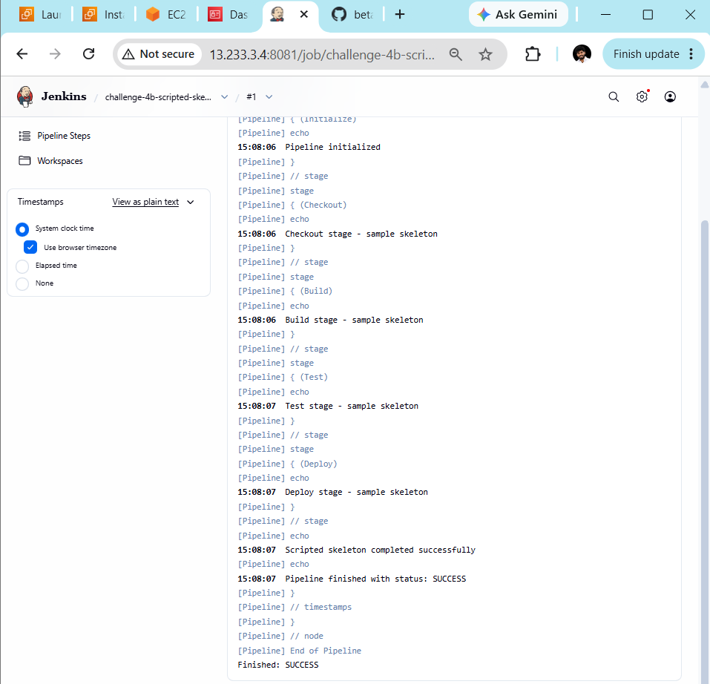

Challenge 5: Simple Customer App Pipeline
Goal: Create a Declarative Pipeline that checks out the feature-1.1 branch, verifies Java and Maven, builds the project, and archives the generated artifact.
Repository: sabear_simplecutomerapp
Branch: feature-1.1
Step 1 — Create a new Jenkins job
- Open your Jenkins dashboard: http://13.233.3.4:8081
- Click New Item.
- Enter this job name:
challenge-5-customer-app-pipeline
- Select Pipeline.
- Click OK.
Step 2 — Configure the Pipeline
Scroll down to the Pipeline section and set:
- Definition: Pipeline script
- Use Groovy Sandbox: Enabled
Step 3 — Paste this Declarative Pipeline

pipeline {
agent any

tools {
jdk 'JDK21'
maven 'Maven3'
}

options {
timestamps()
}

stages {
stage('Checkout') {
steps {
git branch: 'feature-1.1',
url: 'https://github.com/betawins/sabear_simplecutomerapp.git'
}
}

stage('Verify Tools') {
steps {
sh '''
echo "===== Java Version ====="
java -version

echo "===== Maven Version ====="
mvn -version

echo "===== Project Files ====="
ls -la
'''
}
}

stage('Build') {
steps {
sh 'mvn clean package'
}
}

stage('Archive Artifact') {
steps {
archiveArtifacts artifacts: '**/target/*.war, **/target/*.jar',
allowEmptyArchive: false,
fingerprint: true
}
}
}

post {
success {
echo 'Challenge 5: Customer App pipeline completed successfully!'
}

failure {
echo 'Pipeline failed. Check Console Output.'
}

always {
echo 'Pipeline execution finished.'
}
}
}
Before running: Confirm that feature-1.1 exists in the repository and check the project's pom.xml for its required Java version. Unlike Challenge 1, we should not assume this application uses the same Maven configuration.
Step 4 — Save and build
- Click Save.
- Click Build Now.
- Open the latest build from Build History.
- Click Console Output.
Step 5 — Verify the stages
Expected stages:
- Checkout
- Verify Tools
- Build
- Archive Artifact
The final status should be Finished: SUCCESS.
Step 6 — Troubleshooting
Error | What to do
Branch not found | Confirm the exact branch name on GitHub.
Maven pom.xml not found | Check whether the project is inside a subdirectory and run Maven from that directory.
Java source/target error | Inspect the project's Java version settings before changing them.
No artifact found | Check the Maven output to determine whether it generated a JAR or WAR.
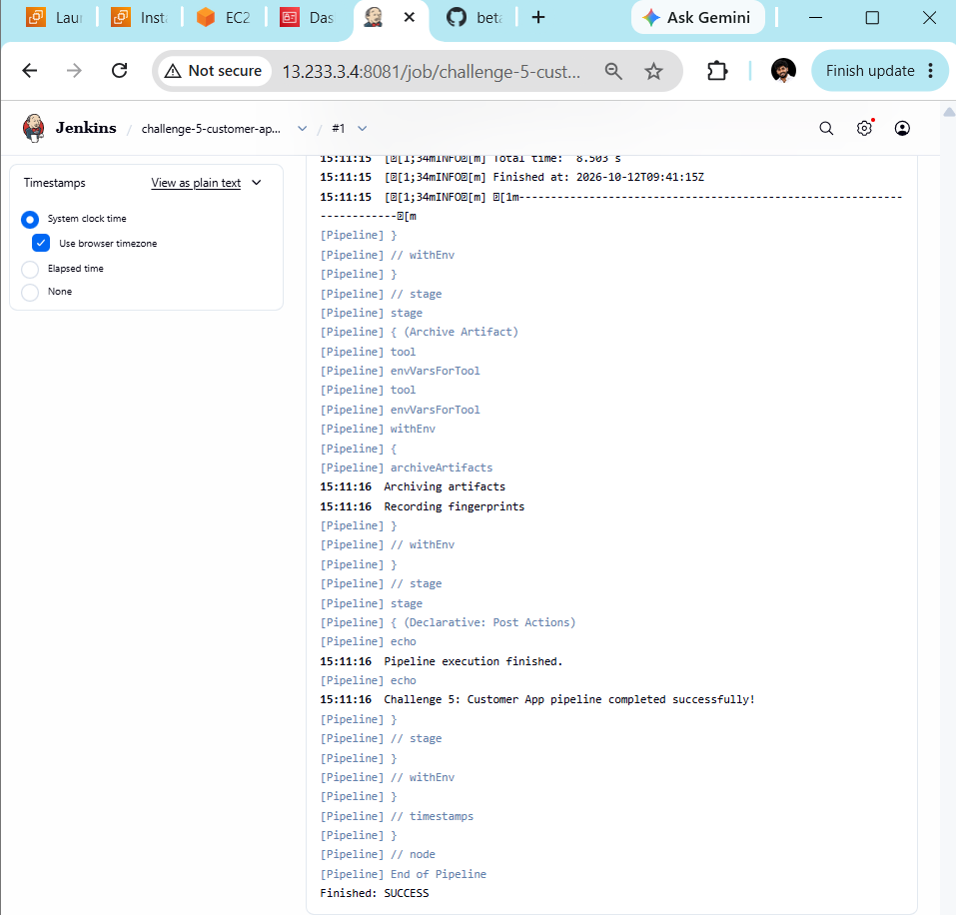

Challenge 6 — Trading-UI Pipeline
We'll create another Declarative Pipeline using the Trading-UI repository.
Repository: betawins/Trading-UI
Step 1 — Create a Jenkins job
- Open your Jenkins dashboard: http://13.233.3.4:8081
- Click New Item.
- Enter the job name:
challenge-6-trading-ui-pipeline
- Select Pipeline.
- Click OK.
Step 2 — Configure the Pipeline
Scroll down to Pipeline and select:
- Definition: Pipeline script
- Use Groovy Sandbox: Enabled
Step 3 — Paste this Declarative Pipeline

pipeline {
agent any

tools {
jdk 'JDK21'
maven 'Maven3'
}

options {
timestamps()
}

stages {
stage('Checkout') {
steps {
git url: 'https://github.com/betawins/Trading-UI.git'
}
}

stage('Inspect Project') {
steps {
sh '''
echo "===== Java Version ====="
java -version

echo "===== Maven Version ====="
mvn -version

echo "===== Project Files ====="
ls -la

echo "===== Build Files ====="
find . -maxdepth 3 \\( -name pom.xml -o -name package.json -o -name build.gradle \\) -print
'''
}
}

stage('Build') {
steps {
script {
if (fileExists('pom.xml')) {
sh 'mvn -Djdk.version=1.8 clean package'
} else if (fileExists('package.json')) {
echo 'Node.js project detected. Inspect package.json before selecting the build command.'
sh 'cat package.json'
} else {
error 'No pom.xml or package.json found at the repository root. Inspect the project structure before building.'
}
}
}
}
}

post {
success {
echo 'Challenge 6: Trading-UI pipeline completed successfully!'
}

failure {
echo 'Pipeline failed. Check Console Output.'
}

always {
echo 'Pipeline execution finished.'
}
}
}
Important, mama: Trading-UI may use a different build system or require a specific Node.js version. This pipeline checks the project structure first instead of blindly assuming it is a Maven application. If it is a Node.js project, the build stage intentionally stops after inspecting package.json so we can configure the correct build command.
Step 4 — Save and run
- Click Save.
- Click Build Now.
- Open the latest build.
- Click Console Output.
Step 5 — Verify
Confirm that checkout succeeds and inspect the output from Inspect Project to identify the project's build system.
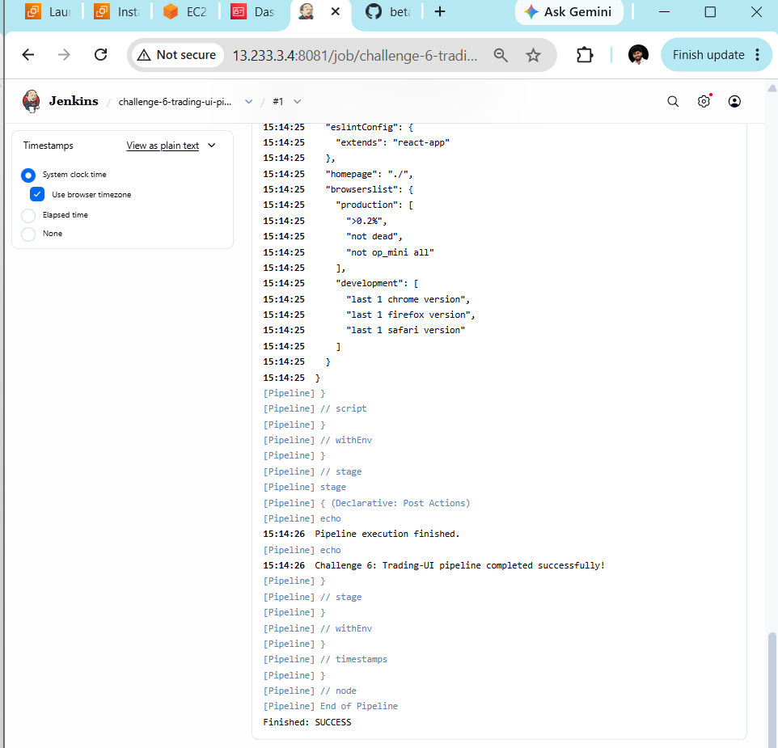

Challenge 7 — Parallel Stages Pipeline
Objective: Run multiple stages in parallel so that independent tasks can execute simultaneously.
Step 1 — Create a Jenkins job
- Open Jenkins: http://13.233.3.4:8081
- Click New Item.
- Enter the name:
challenge-7-parallel-stages
4. Select Pipeline and click OK.
Step 2 — Configure the Pipeline
Scroll down to Pipeline.
- Definition: Pipeline script
- Use Groovy Sandbox: Enabled
Step 3 — Paste this Jenkinsfile

pipeline {
agent any

options {
timestamps()
}

stages {
stage('Initialize') {
steps {
echo 'Starting parallel pipeline demonstration'
}
}

stage('Parallel Tasks') {
parallel {
stage('Task A - Linux') {
steps {
sh '''
echo "Task A started"
sleep 5
echo "Task A completed"
'''
}
}

stage('Task B - Git') {
steps {
sh '''
echo "Task B started"
git --version
sleep 5
echo "Task B completed"
'''
}
}

stage('Task C - Java') {
steps {
sh '''
echo "Task C started"
java -version
sleep 5
echo "Task C completed"
'''
}
}
}
}

stage('Final Status') {
steps {
echo 'All parallel tasks completed'
}
}
}

post {
success {
echo 'Challenge 7: Parallel stages completed successfully!'
}

failure {
echo 'Parallel pipeline failed. Check Console Output.'
}

always {
echo 'Pipeline execution finished.'
}
}
}
Step 4 — Save and run
- Click Save.
- Click Build Now.
- Open the latest build.
- Check Console Output and the Stage View if available.
Step 5 — Verify the result
You should see the three tasks under Parallel Tasks:
- Task A — Linux
- Task B — Git
- Task C — Java
They can execute concurrently, provided Jenkins has enough executor capacity. Each task includes a five-second delay to make the parallel execution easier to observe.
The final result should be:
Finished: SUCCESS
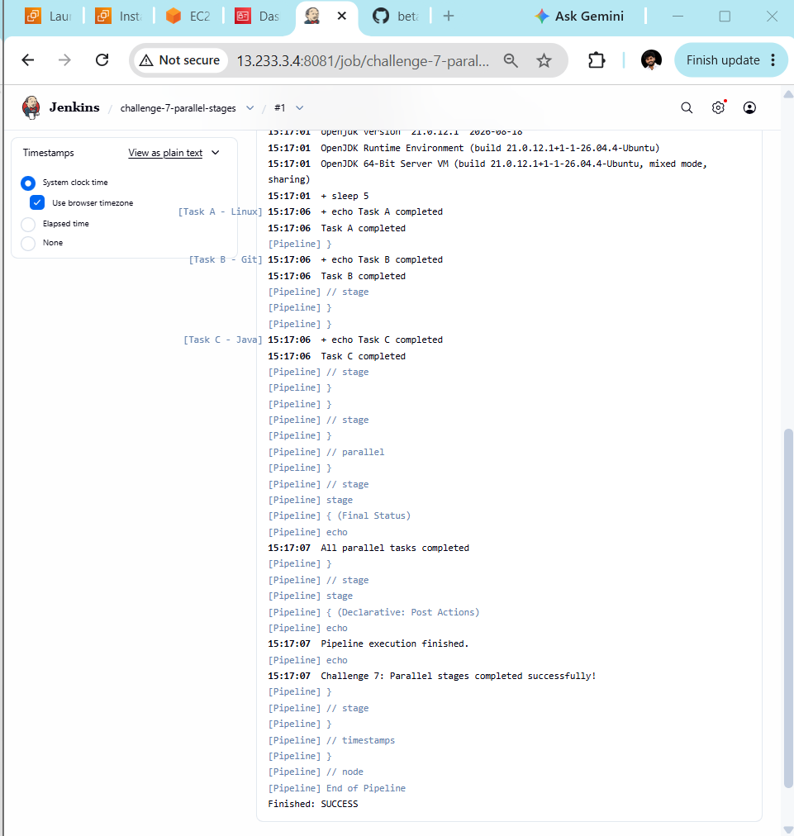

Challenge 8 — Jenkins Shared Library
Objective: Create reusable pipeline code in a GitHub repository and call it from a Jenkins pipeline. This is the final challenge, mama!
Step 1 — Understand the concept
A Jenkins Shared Library lets you reuse common pipeline code across multiple Jenkins jobs instead of copying the same code into every Jenkinsfile.
Shared Library in GitHub
Reusable pipeline functions
Jenkins Global Pipeline Libraries
Configure library name and repository
Jenkinsfile
Calls reusable library functions
We'll create a small working library ourselves so you can see the complete process.
Step 2 — Create a GitHub repository
- Open GitHub.
- Click New repository.
- Repository name: jenkins-shared-library
- Select Public for this practice exercise, or use a private repository with Jenkins credentials configured.
- Initialize with a README and click Create repository.
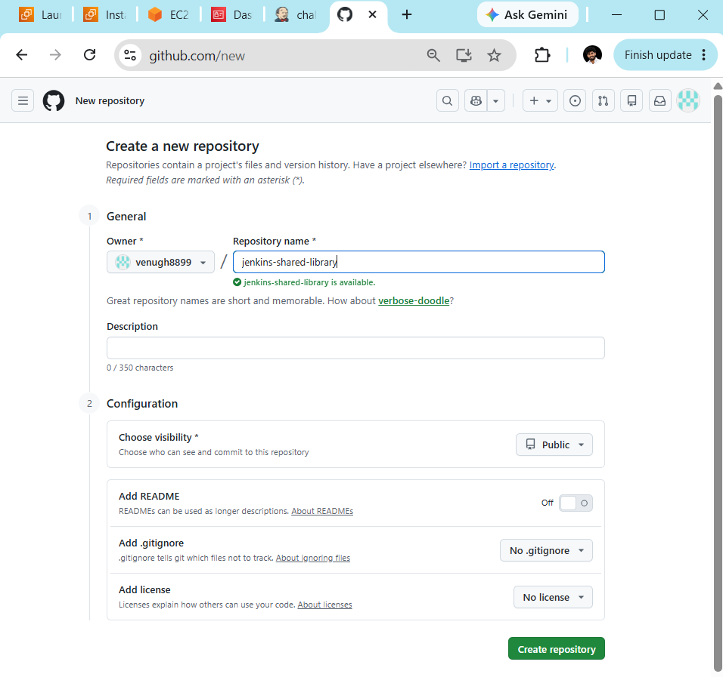
Step 3 — Create the Shared Library structure
Inside the new repository, create these files:
jenkins-shared-library/
├── vars/
│ ├── sayHello.groovy
│ └── runChecks.groovy
└── README.md
File 1: vars/sayHello.groovy
def call(String name = 'Mama') {
echo "Hello ${name}! Welcome to Jenkins Shared Libraries."
}
File 2: vars/runChecks.groovy
def call() {
stage('Library - Linux Check') {
sh 'echo "Linux check completed"'
}

stage('Library - Git Check') {
sh 'git --version'
}

stage('Library - Java Check') {
sh 'java -version'
}
}
Commit both files to the repository's main branch. If you use another default branch, we'll configure Jenkins accordingly.
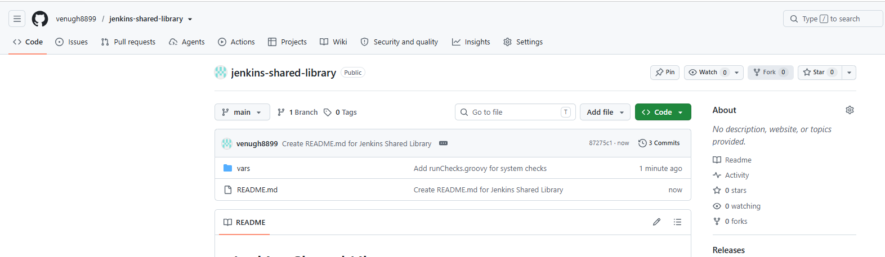
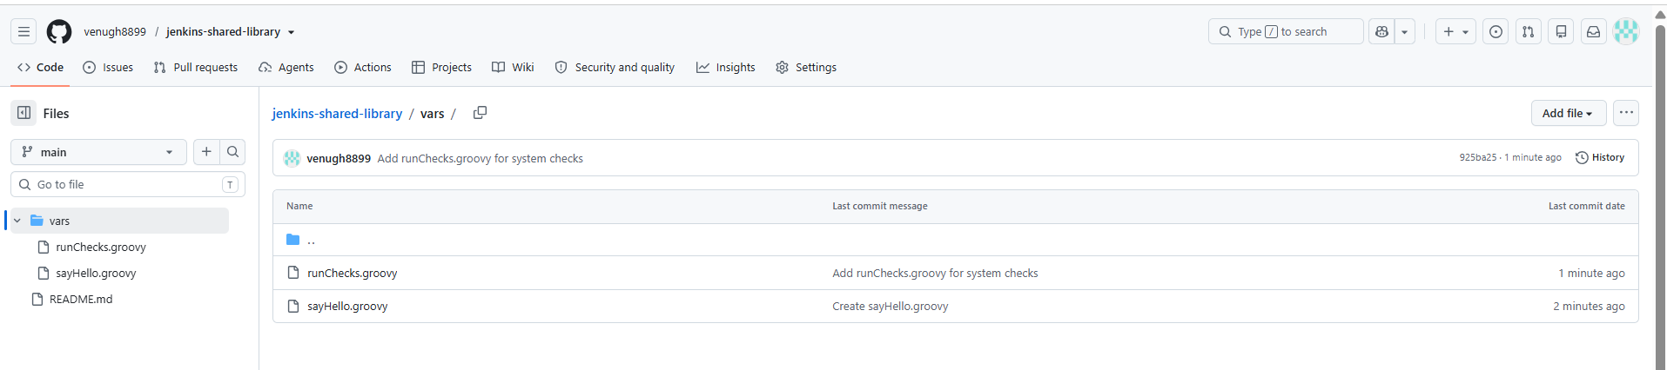
Step 4 — Configure the Global Shared Library in Jenkins
- Open Jenkins.
- Click Manage Jenkins.
- Open System or Configure System (the menu label varies by Jenkins version).
- Find Global Pipeline Libraries.
- Click Add.
Enter these settings:
Setting | Value
Name | my-shared-library
Default version | main
Retrieval method | Modern SCM
Source Code Management | Git
Project Repository | Your new jenkins-shared-library GitHub URL
For example, the repository URL will be:
https://github.com/YOUR-GITHUB-USERNAME/jenkins-shared-library.git
Replace YOUR-GITHUB-USERNAME with your actual GitHub username.
Leave automatic version selection disabled unless you specifically need it. If using a private repository, configure the appropriate credentials.
Click Save.
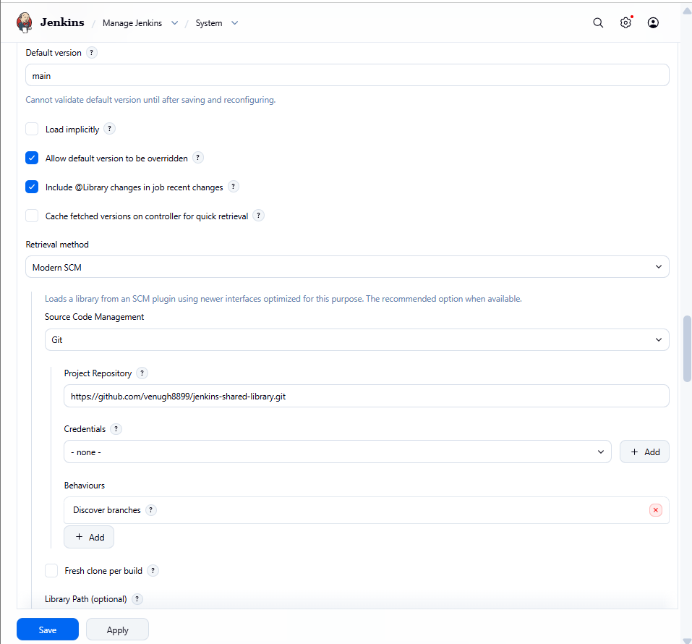
Step 5 — Create the Jenkins job
- Click New Item.
- Name it:
challenge-8-shared-library
- Select Pipeline.
- Click OK.
- Under Pipeline, select Pipeline script.
Step 6 — Paste the Jenkinsfile

@Library('my-shared-library') _

pipeline {
agent any

options {
timestamps()
}

stages {
stage('Welcome') {
steps {
sayHello('Venu')
}
}

stage('Run Shared Checks') {
steps {
runChecks()
}
}

stage('Final Message') {
steps {
echo 'Shared Library pipeline completed!'
}
}
}

post {
success {
echo 'Challenge 8: Jenkins Shared Library completed successfully!'
}

failure {
echo 'Shared Library pipeline failed. Check Console Output.'
}

always {
echo 'Pipeline execution finished.'
}
}
}
Notice that sayHello('Venu') and runChecks() are loaded from the shared library. They are not defined inside this Jenkinsfile.
Step 7 — Save and run
- Click Save.
- Click Build Now.
- Open Console Output.
- Verify the output includes:
  - Hello Venu! Welcome to Jenkins Shared Libraries.
  - Linux check completed
  - Git version output
  - Java version output
  - Finished: SUCCESS
